**Ideation Phase**

**Define the Problem Statements**

| Date | 30 october 2025 |
| --- | --- |
| Team ID | NM2025TMID03158 |
| Project Name | Educational Organization using ServiceNow |
| Maximum Marks | 2 Marks |

**Customer Problem Statement Template:**

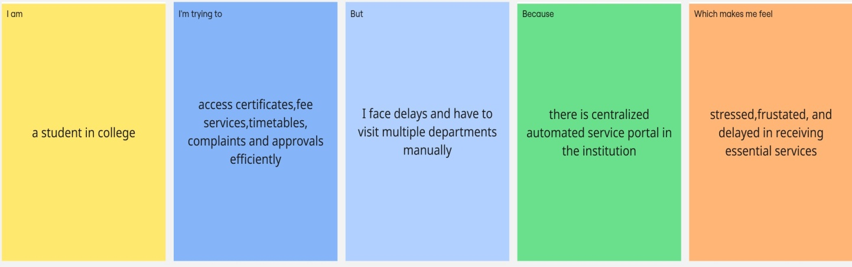

## Problem Statement Table:

| **Problem Statement (PS)** | **I am (Customer)** | **I’m trying to** | **But** | **Because** | **Which makes me feel** |
| --- | --- | --- | --- | --- | --- |
| PS-1 | A student in a college who needs academic and administrative services (certificates, timetable, fees, complaints) | Access student services quickly and get approvals without delays | I have to visit different departments, fill manual forms and wait in long queues | There is no centralized automated system to handle student requests and approvals | Frustrated, stressed, and delayed in completing important academic tasks |
| PS-2 | A faculty/administrative staff member responsible for student requests and academic services | Manage student queries, approvals, notices, and academic records efficiently | I spend time on manual paperwork, approval cycles, and repetitive tasks | The institution lacks an automated workflow management and notification system | Overloaded, time-pressed, and unable to respond to student requests efficiently |